INTERNSHIP REPORT
on
Adoption of Contact Centre Services among Customers
for Better Experience in the State Bank of India
performed under
STATE BANK OF INDIA —DIGITAL & TRANSFER BANKING DEPARTMENT
Submitted by:
PRIYADARSHINI SHARMA
B.Tech, Computer Science & Engineering, 2nd Year
Amity University, Kolkata
Roll No.: A91005224037

Live Demo: https://sbi-multilingual-contact-centre.streamlit.app
Source Code: https://github.com/Priyadarshini-Sharma/sbi-multilingual-contact-centre

STATE BANK OF INDIA
L & D Department
2026

ACKNOWLEDGEMENT
I take this opportunity to express my sincere gratitude to my mentor, Shri Bhaskar Debnath, Chief Manager (Digital & e-Comm) for the guidance, feedback, and encouragement provided throughout the course of this internship. The direction given at each stage of design and testing was invaluable in shaping this project.
I am also grateful to the Mr. Debasis Nandy AGM and the entire Learning and Development Department, for this opportunity to work on a real operational problem facing the bank's contact centre infrastructure, and for the support extended during this engagement.
I would also like to thank my faculty guide at Amity University, Kolkata, for the continued academic support and cooperation during this internship. This project wouldn’t be possible without the encouragement of my parents and friends.

Priyadarshini Sharma
Amity University, Kolkata
July 2026

ABSTRACT
The State Bank of India (SBI) operates one of the largest contact centre infrastructures in the country, handling approximately 1.5 crore calls per month across four toll-free lines in over a dozen languages. Despite this scale, the bank's own leadership has publicly identified customer awareness and adoption — not capacity as the primary bottleneck limiting the contact centre's effectiveness. Customers routinely abandon calls due to rigid Dual-Tone Multi-Frequency (DTMF) menu structures, face friction when their spoken language does not match an available agent, and experience low First-Call Resolution (FCR), which in turn drives unnecessary branch visits and elevated grievance volumes.
This report documents the design, implementation, and evaluation of a proof-of-concept Intelligent, Emotion-Aware, Multilingual Contact Centre Engine, developed during a summer internship with the SBI D & TB. The system replaces static IVR menus with a conversational pipeline that translates and transcribes customer speech, classifies intent across nine banking service categories, performs real-time sentiment analysis to detect customer distress, and predictively routes each caller to the best-matched human agent using a weighted, multi-factor optimization score.
The system was validated through a 65-respondent primary survey, a 25-case manual test transcript set spanning 14 languages and 9 intents, and a 1,000-call synthetic operational simulation. Results showed an improvement in First-Call Resolution from 48% (traditional IVR baseline) to 79% (proposed system), a reduction in customer churn risk from 14% to 3%, a 6-percentage-point increase in the share of calls resolved without a branch visit (11% to 17%), and an improvement in average per-call sentiment recovery from +0.53 to +0.63. This report situates these results within the broader academic literature on technology adoption in Indian banking (TAM/UTAUT frameworks) and argues that closing SBI's adoption gap requires addressing ease-of-use and perceived usefulness for specific underserved segments — elderly customers and regional-language speakers — rather than simply adding channel capacity. A working proof-of-concept, source code, and this report are available at the links on the title page.

TABLE OF CONTENTS
Acknowledgement 2
Abstract 3
Chapter 1: Introduction 6
1.1 Background of Public Sector Banking in India 6
1.2 Statement of the Problem 6
1.3 Motivation 6
1.4 Objectives and Scope of the Project 7
1.5 Organization of the Report 7
Chapter 2: Literature Review 8
2.1 Contact Centre / IVR Adoption in Indian Banking 8
2.2 Technology Adoption Theories — TAM and UTAUT 8
2.3 Barriers to Adoption 8
2.4 Speech-to-Speech Translation and Sentiment Analysis Literature 9
2.5 Predictive Call Routing Literature 9
2.6 Research Gap 9
Chapter 3: System Requirements and Methodology 10
3.1 Functional Requirements 10
3.2 Non-Functional Requirements 10
3.3 Technology Stack Justification 10
3.4 Research Methodology 11
Chapter 4: System Architecture and Design 13
4.1 High-Level Architecture 13
4.2 NLP Engine Design 14
4.3 Predictive Routing Algorithm 15
4.4 Database Schema 16
4.5 Session Store Design 17
4.6 UI/UX Design 17
4.7 Five New Value-Added Services (Branch Deflection Strategy) 17
4.8 Gap Analysis Against SBI's Existing Service Catalogue 19
Chapter 5: Implementation 20
5.1 Repository Structure 20
5.2 End-to-End Walkthrough of a Live Session 20
5.3 Key Algorithms 23
5.4 Synthetic Data Generation 24
5.5 Engineering Challenges and Decisions 24
Chapter 6: Testing and Results 25
6.1 Manual Test Suite 25
6.2 Primary Survey Results (n = 65) 25
6.3 Synthetic Operational Simulation Results (n = 1,000 calls) 27
6.4 Comparative Assessment: Why the Proposed System Outperforms the Existing Channel 30
Chapter 7: Discussion — Adoption Implications 31
7.1 Mapping Results to Adoption Theory 31
7.2 Who Benefits Most 31
7.3 Limitations 31
Chapter 8: Conclusion and Future Scope 32
References 33
Appendices 34

Chapter 1: Introduction

1.1 Background of Public Sector Banking in India
The Indian retail banking landscape is undergoing structural shifts characterised by compressed Net Interest Margins, escalating operating costs, and intensifying competition from digital-first private banks. Retail banking assets have expanded from roughly 28% of assets under management in FY2018 to about 35% in FY2025, and a low reported Gross Non-Performing Asset ratio (around 2.2%) is partly masked by elevated retail loan write-offs. A widening credit-to-deposit gap means deposit mobilisation has not kept pace with credit growth, pushing banks to defend deposit bases by improving customer experience across every retail touchpoint, especially the contact centre.
As the largest public sector bank in India, SBI manages a vast and heterogeneous customer base spanning multiple languages, socioeconomic strata, and levels of digital literacy. Its legacy voice-menu infrastructure, reachable via toll-free numbers such as 1800 1234, 1800 2100, 1800 11 2211, and 1800 425 3800, relies on Dual-Tone Multi-Frequency (DTMF) navigation that places a heavy cognitive load on callers, particularly elderly and rural customers.

1.2 Statement of the Problem
SBI's contact centre was modernised under Project Dhruva (launched 2021) and today handles approximately 1.5 crore monthly calls, with around 40% self-serviced through IVR and the remainder handled by more than 3,500 tele-callers across four toll-free lines and 12–15 languages. Despite this scale, SBI's own chairman has publicly framed the bank's forward priority not as expanding capacity but as building customer awareness and adoption of the contact centre — an explicit admission that the primary constraint is behavioural and experiential, not infrastructural.
Three intersecting pain points define the problem this project addresses:
- Language exclusion — routing systems built around English/Hindi leave regional-language speakers underserved.
- Rigid, menu-driven routing — DTMF trees route by keypress, not by actual understanding of the customer's problem or emotional state.
- Unnecessary branch overcrowding — service requests that could be resolved remotely (YONO co-browsing, deceased-account claims, fraud locks) currently force a physical branch visit.

1.3 Motivation
To validate the scale of these problems independently, a primary survey of 65 real respondents was conducted. The survey found that 83% of respondents had abandoned a bank call at some point due to wait time or menu confusion, and 43% had experienced language friction when speaking with a representative. These figures directly motivated the system's design priorities: conversational (not keypad-driven) interaction, native multilingual support, and sentiment-aware escalation.

1.4 Objectives and Scope of the Project
- To design and simulate an intelligent, multilingual, emotion-aware contact centre routing engine as a proof-of-concept.
- To replace static IVR menus with a conversational pipeline covering translation, intent classification, and sentiment analysis.
- To implement a predictive, multi-weighted routing algorithm for caller-to-agent matching.
- To validate the system's impact on First-Call Resolution, churn risk, and branch-visit deflection using synthetic operational data.
- To situate the system's design choices within the academic literature on technology adoption in Indian banking.
The scope of this project is limited to a simulated proof-of-concept: The local equivalents of live telephony, production Bhashini integration, and a production-grade Redis cluster are implemented, appropriate to a student internship engagement rather than a deployed production system.

1.5 Organization of the Report
Chapter 2 reviews the academic and industry literature on contact-centre adoption in Indian banking. Chapter 3 details the system requirements and research methodology. Chapter 4 presents the system architecture. Chapter 5 covers implementation details. Chapter 6 presents testing and results. Chapter 7 discusses the adoption implications of the results. Chapter 8 concludes with a summary and future scope.

Chapter 2: Literature Review

2.1 Contact Centre / IVR Adoption in Indian Banking
SBI's contact centre is not under-built — it is under-used relative to its own capability. Following its 2022 relaunch, the centre already offered 30-plus banking solutions in 12 languages, 24x7, with roughly 40% of the 1.5-crore monthly call volume resolved through self-service IVR. SBI's own leadership has stated that future investment will focus on building customer awareness and adoption of the contact centre, rather than further expanding capacity — a strong indication that adoption, not infrastructure, is the binding constraint this project addresses.
At an industry level, IVR handled approximately 25% of India's 1.2 billion annual banking calls by 2022, cutting BFSI operational costs by roughly 30%, according to FICCI-KPMG estimates. Yet traditional IVR is documented to fail specifically for low-literacy and non-metro customers: one industry analysis attributes roughly 55% of rural call drop-offs to poor multilingual support in existing IVR systems.

2.2 Technology Adoption Theories — TAM and UTAUT
Two theoretical frameworks dominate the study of technology adoption in Indian banking. The Technology Acceptance Model (TAM) explains adoption through perceived usefulness and perceived ease of use. The Unified Theory of Acceptance and Use of Technology (UTAUT) extends this with performance expectancy, effort expectancy, social influence, and facilitating conditions. A systematic literature review of banking-sector technology adoption identifies TAM and UTAUT as the two most widely used and empirically validated frameworks in this domain.
Indian-context UTAUT studies on e-banking adoption have found that performance expectancy, social influence, and effort expectancy significantly shape a customer's intention to use a service, while facilitating conditions alone do not reliably predict adoption. This distinction matters for contact-centre design: simply making a channel available (a facilitating condition) is insufficient — the channel must also be perceived as easy to use and genuinely useful, which is precisely the gap a conversational, multilingual interface is designed to close relative to a DTMF menu.

2.3 Barriers to Adoption
Documented barriers to contact-centre and IVR adoption cluster around three groups:
- Age and digital literacy: elderly customers struggle specifically with IVR navigation; complex menu journeys are reported to provide little incentive for older customers to engage with digital or voice-assisted banking channels at all.
- Language and rural exclusion: low literacy and language mismatch are documented causes of call abandonment in rural and non-metro segments, independent of network or infrastructure quality.
- Grievance-redressal strain: low First-Call Resolution compounds into a broader grievance burden — nationally, RBI Ombudsman complaints against regulated entities rose 13.55% in FY2024-25 to 13.34 lakh, with banks accounting for over 81% of all complaints received.

2.4 Speech-to-Speech Translation and Sentiment Analysis Literature
India's national Bhashini AI initiative provides ASR (Automatic Speech Recognition), Neural Machine Translation, and Text-to-Speech pipelines for Indian languages, orchestrated through a stateful pipeline session (the Dhruva orchestrator). Academic and industry sources document a cascaded three-hop pipeline — Speech-to-Text, Machine Translation, Text-to-Speech — as the standard architecture for multilingual voice systems, while noting that each hop introduces serialisation latency and compounding transcription error, motivating research toward single-hop audio-to-audio translation models.
For sentiment inference specifically, IndicBERT-family models (e.g., ai4bharat/IndicBERTv2-alpha-SentimentClassification) provide subword-tokenised sentiment classification suited to compound Indian-language words. A sliding-window buffering approach — accumulating 12–15 words of transcribed text with a 10–15% overlap between windows — is documented as necessary to give sentiment classifiers sufficient semantic context without sacrificing the low-latency responsiveness required for real-time transcription.

2.5 Predictive Call Routing Literature
Industry literature on predictive/intelligent call routing (Genesys, Bland.ai, Smith.ai) consistently frames routing as a multi-factor optimisation problem rather than a simple first-available queue: agent skill match, language compatibility, and current occupancy/workload are the three variables most commonly cited as inputs to a routing score, with the objective of maximising First-Call Resolution while avoiding agent burnout from workload concentration on top performers.

2.6 Research Gap
While there is substantial literature on (a) SBI's contact-centre scale and its self-acknowledged adoption gap, (b) general technology-adoption theory (TAM/UTAUT) as applied to Indian e-banking, and (c) the individual technical components (Bhashini-style translation, IndicBERT sentiment analysis, predictive routing formulas), there is limited published work that integrates all three into a single evaluated system specifically targeted at SBI's contact-centre context. This project addresses that gap by building, testing, and evaluating an integrated system and explicitly connecting its design choices back to documented adoption barriers.

Chapter 3: System Requirements and Methodology

3.1 Functional Requirements
The system is required to classify customer intent across nine service categories: the five original categories (Balance Inquiry, Loans, Fraud, Pension, General) plus five special categories added — Deceased Claim Facilitation, YONO Co-Browsing, Proactive Fraud Lock, Video Banking Advisory, and Passive Voice Biometrics (the last of which functions as a continuous authentication check rather than a discrete request).

3.2 Non-Functional Requirements
- End-to-end pipeline latency target of under 2 seconds for the speech-to-speech translation loop.
- Routing computation fail-safe: if the matching calculation exceeds 150 ms or no agents are available, the system returns an HTTP 503 with a default fallback queue rather than dropping the call.
- Graceful degradation at every failure point — no Hugging Face model available falls back to a rule-based sentiment scorer; no Redis available falls back to an in-memory dictionary; no ideal agent match falls back to the least-busy general agent.

3.3 Technology Stack Justification
Every major component was chosen deliberately against at least one realistic alternative, rather than defaulted to. The comparison below makes that reasoning explicit rather than leaving it implied.
Component | Chosen | Alternative Considered | Why the Chosen Option Won for This Project
Front-end | Streamlit | Flask/Django + custom HTML/JS | A full custom stack would demonstrate front-end engineering, but this project's contribution is the NLP and routing pipeline, not UI engineering; Streamlit reaches a usable, shareable, deployable interface in a fraction of the time, leaving time for the algorithmic work.
Database | SQLite | PostgreSQL / MySQL | Zero server setup, a single portable file, and no hosting dependency — appropriate for a proof-of-concept evaluated locally and on Streamlit Community Cloud; the schema itself (Section 4.4) is standard relational SQL and would port to Postgres with no redesign.
Translation | deep-translator (Google Translate) + a small hardcoded phrase dictionary | Direct Bhashini API integration | Bhashini access requires registration and API credentials not available within the internship's scope and timeline; deep-translator provides an equivalent input/output contract (regional text in, English text out) so the rest of the pipeline is unaffected when the real API is substituted later (Chapter 8).
Sentiment model | Hugging Face tabularis.ai/multilingual-sentiment-analysis (open-weight, self-hosted) | A commercial sentiment API (e.g. a paid cloud NLP service) | An open-weight model avoids per-call API costs and rate limits, runs offline once cached, and its known weaknesses (Section 5.5) are fully inspectable and explainable in this report — a paid black-box API's failure modes would not be.
Intent classification | Ordered keyword matching | A fine-tuned or zero-shot LLM classifier | Keyword matching is fully deterministic and auditable — every misclassification in Chapter 6 could be traced to an exact cause. An LLM classifier would likely score higher on raw accuracy but would trade away exactly the auditability this report relies on for its failure-mode analysis (Section 5.5); keyword matching was the right choice for a project that needed to explain its own mistakes precisely.
Session store | Redis with automatic in-memory fallback | No session layer (stateless per-call only) | A session layer is what allows a rolling sentiment history to be captured at all (Section 4.1); the in-memory fallback means the demo works even without a hosted Redis instance, at the cost of losing history on process restart — an acceptable trade for a proof-of-concept.

The concrete dependency stack, pinned in requirements.txt, is: Streamlit ≥1.35 (front-end), deep-translator ≥1.11 (mocked translation layer), Transformers ≥4.40 with PyTorch ≥2.2 and torchvision ≥0.17 (sentiment model), redis-py ≥5.0 (session store), and pandas / Faker / NumPy for the synthetic analytics pipeline (Section 5.4). These substitutions relative to a production Bhashini/enterprise stack are noted explicitly as limitations in Chapter 7 and do not affect the validity of the architectural or algorithmic contributions.

3.4 Research Methodology
A primary survey was administered to 65 respondents to independently quantify the scale of call abandonment and language friction described in Chapter 1. In parallel, a 25-case manual test transcript set was constructed spanning six languages and all nine intent categories, to validate the NLP pipeline's intent-classification and sentiment-detection accuracy under controlled, known-ground-truth conditions. A 1,000-row synthetic operational log was generated using the Faker library to simulate a full year of call-centre activity at a scale sufficient for meaningful before/after comparison against a traditional-IVR baseline.

Chapter 4: System Architecture and Design

4.1 High-Level Architecture
The system pipeline, reproduced from the project's own architecture diagram, is shown in Figure 4.1. Each call moves through nine stages in sequence:
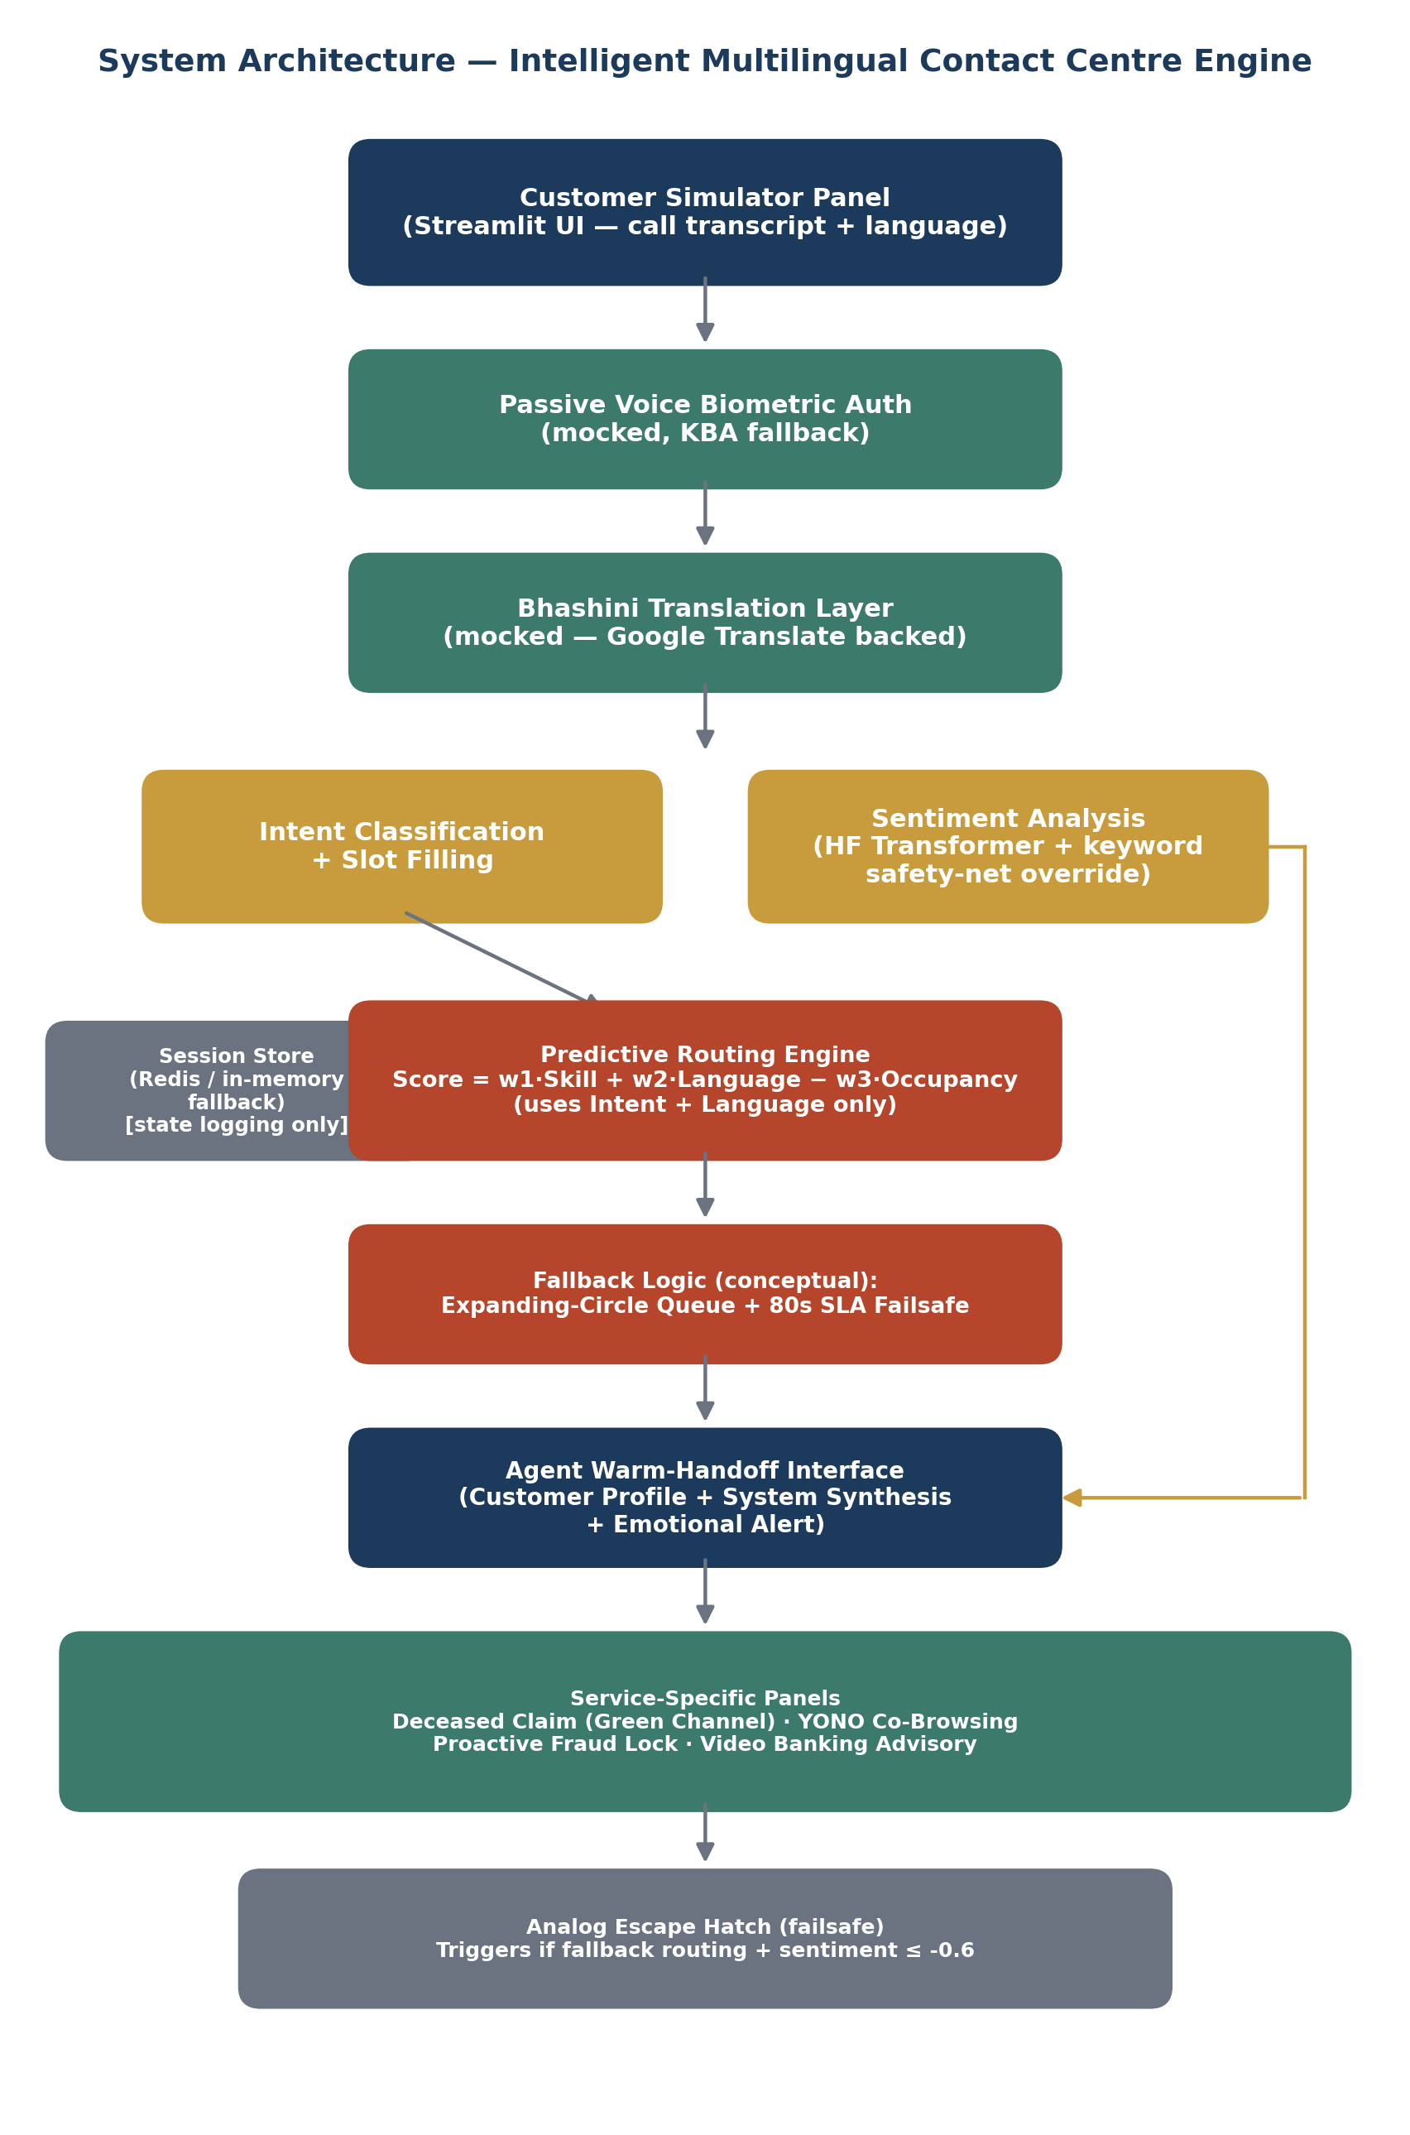
Figure 4.1: System architecture of the Intelligent Multilingual Contact Centre Engine, as implemented.
- Customer Simulator Panel (Streamlit UI): captures the call transcript and the caller's declared native language.
- Passive Voice Biometric Auth (mocked, with Knowledge-Based-Authentication fallback): authenticates the caller before any service request is processed.
- Bhashini Translation Layer (mocked, Google-Translate-backed): normalises the transcript into English for downstream processing.
- Intent Classification + Slot Filling and Sentiment Analysis (Hugging Face transformer with a keyword safety-net override) run in parallel on the translated text.
- Predictive Routing Engine: computes Score = w1·Skill + w2·Language − w3·Occupancy using only the extracted intent and detected language as inputs (Section 4.3). The Redis-backed Session Store runs alongside this stage for state logging (rolling sentiment history, call metadata) but is not itself a scoring input.
- Fallback Logic (conceptual): an Expanding-Circle Queue widens the eligible agent pool over time, backstopped by an 80-second SLA failsafe.
- Agent Warm-Handoff Interface: receives the routing decision and, separately, a direct feed from the Sentiment Analysis stage, which is what renders the Emotional Alert banner the agent sees (Section 5.2).
- Service-Specific Panels (Deceased Claim / Green Channel, YONO Co-Browsing, Proactive Fraud Lock, Video Banking Advisory) and, as a last-resort failsafe, the Analog Escape Hatch, which triggers when a call has already been through fallback routing and sentiment has fallen to − 0.6 or below.
A deliberate design decision worth highlighting is that sentiment does not feed into the routing score itself — it flows directly and separately to the agent-facing Warm-Handoff Interface. This means a highly distressed caller is still routed to the specialist best equipped to resolve their specific issue (by intent and language), while the receiving agent is simultaneously flagged to handle the call with extra care. Section 5.4 discusses why this separation was chosen over an earlier design that folded sentiment directly into the matching score.
A permanent record of every call — customer, matched agent, intent, sentiment trajectory, and outcome — is persisted to a SQLite database (database_setup.py) across three tables: Customers, Agents, and CallLogs.

4.2 NLP Engine Design
The NLP engine performs translation, intent classification, and sentiment analysis in sequence. Translation first checks a small hardcoded dictionary of five guaranteed-correct demo banking phrases (Hindi/Marathi) before falling back to Google Translate with auto-detection; any translation failure returns the original text unchanged rather than crashing the pipeline. Intent classification is a lightweight, ordered keyword matcher: categories are deliberately checked in a specific priority order, with narrower, more specific categories such as Deceased Claim Facilitation checked before broader ones such as Fraud or Pension, precisely to avoid a specific complaint being swallowed by a more generic category. Section 5.5 discusses a case where this safeguard was not sufficient.
Sentiment inference uses the tabularis.ai/multilingual-sentiment-analysis Hugging Face model, mapping its five qualitative output classes (Very Negative, Negative, Neutral, Positive, Very Positive) to a normalised emotional index in the range [−1.0, 1.0], where values close to −1 indicate high customer distress. A keyword-based rule override compensates for cases where the model misreads polite phrasing alongside genuine distress (for example, “please lock everything, I'm scared” being misclassified as positive due to the polite register), and a separate rule-based scorer stands in entirely if the Hugging Face model cannot be loaded at all.

4.3 Predictive Routing Algorithm
The core routing decision is computed via a weighted multi-factor score, Score_ij, between caller i and agent j:
$$Score_{ij}=w_{1}S_{ij}+w_{2}L_{ij}-w_{3}O_{j}$$
where the variables are defined as follows:
Variable | Definition
$$S_{ij}$$ | 1.0 if the agent holds the specialty required by the extracted intent (agents may hold more than one specialty); 0.5 if the agent is a General-purpose fallback; 0.1 for any other mismatch.
$$L_{ij}$$ | Binary: 1.0 if the caller's detected language appears in the agent's certified language list, else 0.0.
$$O_{j}$$ | Agent j's current workload score [0.0–1.0], acting as a penalty to prevent overloading top-performing agents.
$w_{1}$, $w_{2}$, $w_{3}$ | Configurable, non-negative weights summing to 1.0. The system default is $w_{1}$ = 0.40 (skill), $w_{2}$ = 0.40 (language), $w_{3}$ = 0.20 (occupancy), adjustable live via sliders in the Streamlit UI.

Agents are scored and ranked, and the routing outcome falls into one of three regimes based on the top score:
Score Range | Outcome
≥ 0.75 (Optimal Score Threshold) | “Optimal match found” — routed immediately, no fallback flag.
0.50 – 0.75 | “Best available match (below optimal threshold)” — still routed to the top-scoring agent, not flagged as fallback.
< 0.50 (Fallback Minimum Score) | Fallback flag raised, but the system still routes to whichever agent scored highest overall, preserving any partial skill/language credit rather than discarding the score entirely.

The routing engine also models an "Expanding-Circle" queue — a decaying acceptance-threshold timeline stepping down every 15 seconds toward the 80-second SLA failsafe. This is wired directly into the live routing decision: calculate_best_agent accepts the call's elapsed wait time and looks up the currently active threshold via current_expanding_circle_threshold, so a call that has been waiting longer is matched against a progressively more lenient bar rather than a fixed one. In the deployed demo, a sidebar control lets the elapsed wait time be simulated directly, and the active threshold is displayed alongside the routing outcome (Section 5.2).

Worked Example from a Live Session
Figure 4.2 reproduces an actual routing computation from the deployed system, for a caller (Ritu, Hindi-speaking) whose intent was classified as Deceased Claim Facilitation with a negative sentiment score:
Agent | Specialties | Languages | Workload | Score
Ananya | Deceased Claims, General | Hindi, English, Punjabi | 0.25 | 0.75
Sneha | General | Bengali, Hindi, English | 0.55 | 0.49
Divya | Loans, Video Advisory | Gujarati, Hindi, English | 0.10 | 0.42
Meera | Video Advisory, Loans | English, Hindi, Odia | 0.30 | 0.38
Rohan | Fraud, YONO Tech | Marathi, Hindi, English | 0.35 | 0.37
Priya | Loans, Deceased Claims | Tamil, English | 0.20 | 0.36
Vikram | YONO Tech, Fraud | English, Hindi, Malayalam | 0.40 | 0.36
Karthik | Fraud | Telugu, Kannada, English | 0.60 | −0.08
Figure 4.2: Worked routing-score computation for a live session (caller Ritu, Deceased Claim Facilitation, Hindi).
Ananya scores exactly at the 0.75 optimal-match threshold, driven by the combination of a direct specialty match (Deceased Claims) and a shared language (Hindi) with comparatively low current workload. Note the wide gap to the second-best agent (Sneha, 0.49) — illustrating why a naive first-available queue would very likely have produced a worse outcome than the specialty-and-language-aware score. Note also that Karthik's negative score is mathematically valid but not clamped to zero — a fraud specialist with no shared language and high current workload can score below zero under the default weights, which is expected behaviour rather than a bug.

4.4 Database Schema
Table | Key Fields
Customers | customer_id (PK), phone_number (unique), name, age, native_language, balance, nominee_status
Agents | agent_id (PK), name, languages, specialty, workload_score, csat_score
CallLogs | call_id (PK), customer_id, agent_id, intent, initial_sentiment, final_sentiment, duration_seconds, fcr_status

4.5 Session Store Design
Active call state — language, extracted intent slots, and a rolling sentiment history — is held in Redis for the duration of a call, with an automatic in-memory Python dictionary fallback if Redis is unreachable. This is the mechanism that allows the system to detect a caller who “has been getting angrier over the last three exchanges,” rather than judging sentiment from a single isolated utterance.

4.6 UI/UX Design
The Streamlit front-end provides distinct panels reflecting the two customer segments identified in the problem statement: a fast, minimal-friction flow for digitally-confident users, and a larger-text, guided flow for senior-citizen users who benefit from more explicit confirmation steps. The agent-facing warm-handoff screen surfaces customer profile, extracted intent, and an emotional-alert banner (e.g. “Customer is highly distressed — skip repetitive verification steps”) before the agent picks up the call.

4.7 Five New Value-Added Services (Branch Deflection Strategy)
Beyond the original five service categories, five additional high-value services were designed and implemented around the branch-deflection strategy suggested informally during the internship — the practice of resolving complex customer issues remotely through the contact centre so that customers never need to visit a physical branch in the first place. Each service targets a specific, well-documented cause of unnecessary branch visits, and together they are designed to serve both digitally hesitant senior citizens and digitally confident younger customers.

4.7.1 YONO Companion — Secure Co-Browsing and Co-Apping
Problem: Elderly and rural customers frequently want to use the YONO app for online transactions but are hesitant to do so unassisted, for fear of pressing the wrong button or falling victim to a scam — leading many to visit a branch simply to have a teller demonstrate the app.
Solution: While on a call with a customer-care agent, the customer can launch a secure, real-time co-browsing session directly from within the YONO app.
Technology: The agent's dashboard receives a secure clone of the customer's app interface via DOM capturing — sharing only structured app elements rather than a full screen-share. Sensitive fields (CVVs, passwords, balances) are automatically masked from the agent's view. The agent can visually highlight on-screen buttons with markers while guiding the customer verbally through the transaction.
Impact: Builds digital trust with senior citizens, eliminates “troubleshooting blindness” for support agents who previously had no visibility into what the customer was seeing, and reduces physical branch queues formed specifically for mobile-app guidance.

4.7.2 Passive Voice Biometrics — Passwordless Authentication
Problem: Senior citizens frequently forget Net Banking passwords or UPI PINs and must visit a branch with physical documents to reset credentials, while traditional Knowledge-Based Authentication (e.g. security questions) both increases handling time and remains vulnerable to fraud.
Solution: Callers are authenticated passively, purely from the characteristics of their spoken voice, with no password or PIN required.
Technology: Incoming speech is compared in real time against a pre-registered voiceprint across over 100 acoustic features (pitch, frequency, cadence). A deepfake-detection layer performs real-time passive liveness detection to guard against AI voice-cloning attacks.
Impact: Verification completes in under three seconds of normal conversation, reducing average handling time by an estimated 30–60 seconds per call and reducing the volume of account-recovery visits to physical branches.

4.7.3 ‘Green Channel’ Deceased Claim Digital Facilitation
Problem: Settling a deceased account holder's bank accounts is one of the most document-heavy and emotionally difficult processes for grieving families, typically requiring three to four separate branch visits due to clerical errors in paperwork.
Solution: A dedicated, end-to-end digital facilitation service for legal heirs and nominees, accessed through a specialised “Compassionate Care” contact-centre queue.
Technology: The specialised agent opens a secure digital workspace; the family uploads death-certificate and KYC documents via a chat link; Optical Character Recognition (OCR) and document-verification APIs validate the submission in real time; on approval, the system issues a Green Channel Fast-Track Token.
Impact: Reduces the number of required physical branch visits to exactly one — solely to sign the final ledger and collect funds — eliminating repeated paperwork friction during an already distressing process.

4.7.4 Proactive AI Fraud Callback and Instant Lock
Problem: Customers who notice a fraudulent transaction currently have to recognise the fraud themselves, locate the correct helpline, and navigate a call queue — all while the fraudulent activity may still be in progress.
Solution: The system proactively calls the customer the moment a suspicious transaction is flagged, rather than waiting for the customer to call in.
Technology: When SBI's transaction-security system flags a high-risk transaction (e.g. an unusually large payment in an unfamiliar location), an outbound voicebot immediately calls the customer to confirm authorisation. A negative response triggers an instant account-freeze command via the API gateway and auto-drafts a dispute ticket.
Impact: Acts within minutes of a suspected fraud event, and reduces the number of customers rushing to a physical branch in a panic to lock down their account.

4.7.5 Virtual Specialist Branch Rooms — High-Value Video Banking
Problem: Younger customers generally avoid physical branches, yet a substantial share of customers still visit branches in person for complex financial decisions such as home-loan planning or investment advisory while smaller-town branches often lack a full-time specialist on-site.
Solution: A one-click, face-to-face video-banking consultation with a centralised specialist advisor, launched directly from the YONO app or a video kiosk installed at a local branch.
Technology: The existing predictive routing engine (Section 4.3) is extended to pair the customer with a specialised advisor working from a centralised hub or remotely, rather than a generalist agent.
Impact: Gives customers premium advisory access without travel, and allows smaller branches to offer full-service specialist support without the overhead of on-site specialist staffing.

4.8 Gap Analysis Against SBI's Existing Service Catalogue
SBI's actual contact-centre service catalogue, as documented internally, already covers a substantial 50 inbound service types — from ATM card blocking and cheque-book issuance to KYC status and FASTag information — split across IVR-only, agent-only, and both-channel availability, plus a further extensive list of outbound campaigns (loan-due reminders, YONO activation drives, welcome calls for new accounts, and similar). This is a genuinely mature, wide-ranging catalogue, and it is worth being precise about exactly where the five new services proposed in this project sit relative to it.
None of the five directly duplicates an existing line item, but three of the five sit adjacent to a related existing service that they meaningfully extend rather than replace:
New Service | Closest Existing Catalogue Item | What Is Actually New
YONO Companion (Co-Browsing) | “YONO Related Queries” (agent-answered, verbal only) | The existing service lets an agent answer a question about YONO over the phone. This new service additionally, allows the agent to see what the customer sees. Co-browsing adds shared, masked screen visibility.
Deceased Claim Facilitation | “Announcing Nomination Status” (IVR-only, status lookup) | The existing service tells a caller whether a nomination is registered. The newly proposed service aims to reduce the hassle of multi-visit to a physical branch down to a single visit to sign the final ledger. This is a new end-to-end workflow, that aims to aid the aggrieved family in the process.
Proactive Fraud Lock | “Unauthorised Transactions Reporting” (agent-only, inbound) | The existing service is inbound: the customer must notice fraud and call in. The proposed service is outbound and proactive — the bank calls the customer within minutes of a system-flagged anomaly, which is a structurally different (and faster) intervention, not a quicker version of the same complaint process.
Passive Voice Biometrics | No existing analogue | This service offers passwordless authentication of any kind; every existing service authenticates the caller via account details, OTP, or agent-verified KYC.
Video Banking Advisory | No existing analogue | This service offers a live video consultation channel instead of just voice-only (IVR or agent call).

Chapter 5: Implementation

5.1 Repository Structure
The full source code is publicly available at the links below; the live proof-of-concept can be tried directly without any setup.
Source Code: https://github.com/Priyadarshini-Sharma/sbi-multilingual-contact-centre
Live Demo: https://sbi-multilingual-contact-centre.streamlit.app

File / Directory | Purpose
app.py | Streamlit front-end, main entry point
nlp_engine.py | Translation + intent + sentiment pipeline
optimizer.py | Predictive routing / agent-matching algorithm
database_setup.py | SQLite schema + synthetic seed data
session_store.py | Redis-backed session/state tracker
generate_analytics.py | Synthetic 1,000-row operational log generator
data/sbi_operational_logs.csv | Synthetic operational call log (1,000 rows)
testing/sbi_test_transcripts.csv | 25-case manual validation test set
docs/ | Architecture diagram, survey dashboard, operational dashboard, UI screenshots

5.2 End-to-End Walkthrough of a Live Session
The following sequence of screenshots, captured from the deployed application, traces a single call end-to-end — from initial customer input through to the specialised service panel — using the same Deceased Claim Facilitation example introduced in Section 4.3.

Step 1: Customer Simulator Panel
The agent-facing configuration panel (left) exposes the routing weights (w1, w2, w3), the SLA failsafe, the optimal-score threshold, and the session-store backend as live, adjustable controls, so the routing behaviour described in Section 4.3 can be tuned and observed directly. The customer-facing panel (right) accepts a scenario preset, an editable call transcript — here entered in romanized Hindi — and the caller's declared native language.
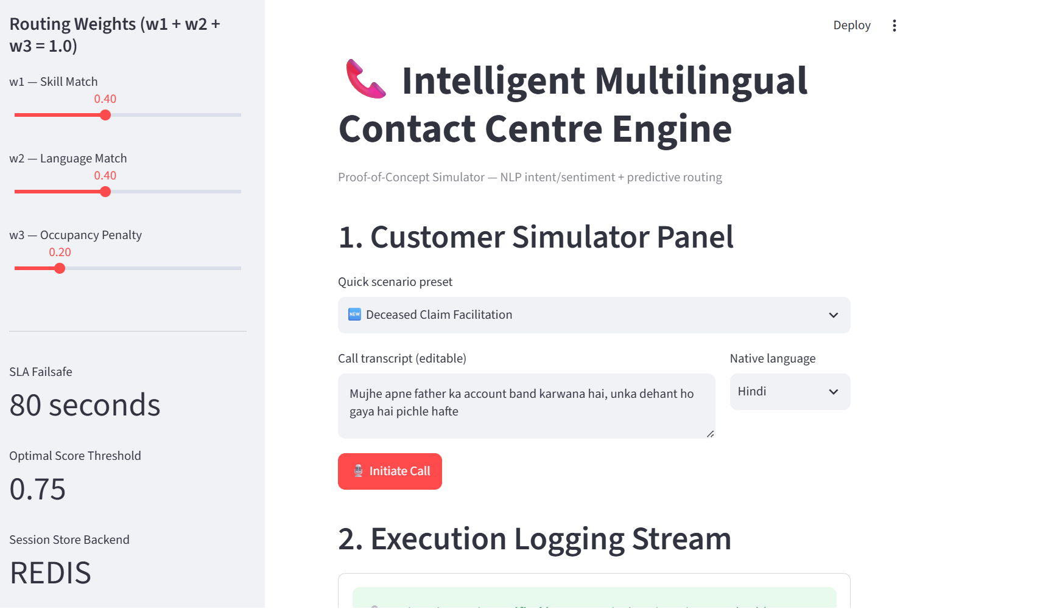
Figure 5.1: Customer Simulator Panel, configured for a Deceased Claim Facilitation scenario in Hindi.

Step 2: Execution Logging Stream
Once the call is initiated, the system streams its own pipeline execution live: passive voice-biometric verification completing in 2.3 seconds (with no password or PIN exchanged), the Bhashini-style translation of the romanized Hindi transcript into English, the extracted intent, and the computed sentiment score. The sentiment engine returns a Negative classification (raw score 0.758, normalised emotional index −0.379), triggering the rolling sentiment history to be written to the Redis session store, before the routing engine computes and displays a live score for every available agent (Section 4.3, Figure 4.2).
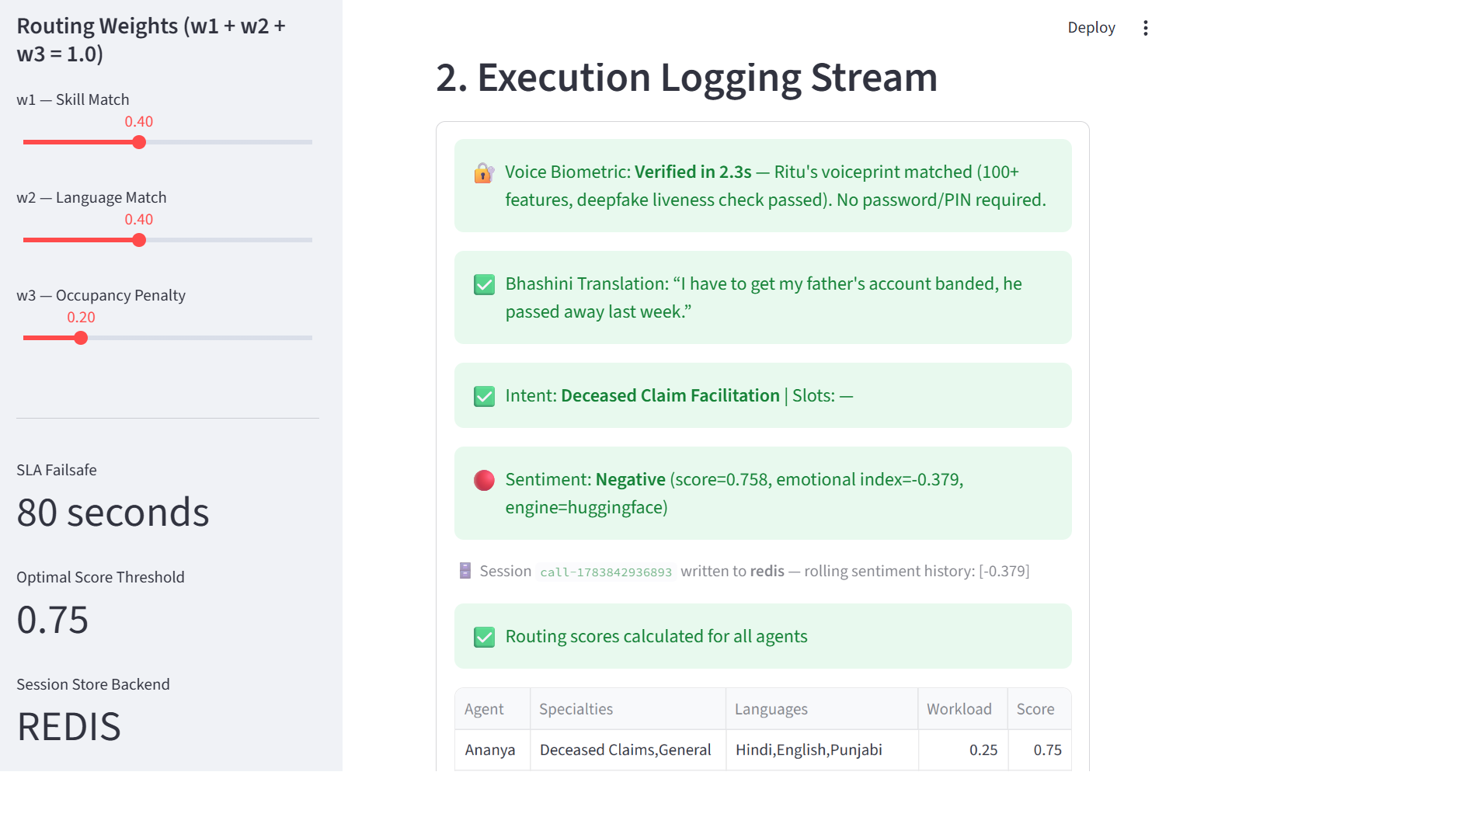
Figure 5.2: Execution Logging Stream showing biometric authentication, translation, intent extraction, and sentiment scoring.

Step 3: Full Routing Table and Agent Terminal
The complete routing table (all eight simulated agents, scored per Section 4.3) is rendered before the system opens the matched agent's terminal — here, Ananya, whose specialty and language match produced the highest score.
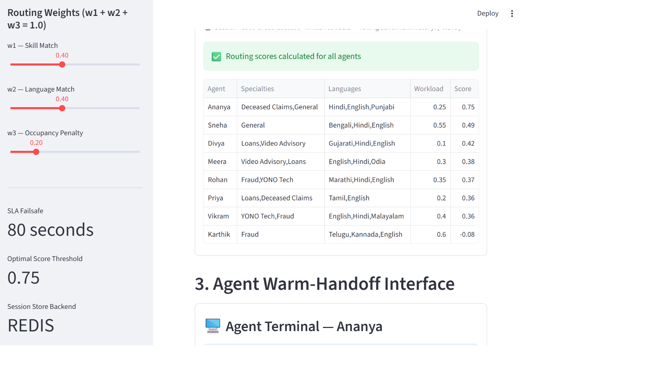
Figure 5.3: Full agent routing table and the opening of the matched agent's terminal.

Step 4: Agent Warm-Handoff Interface
The agent's terminal opens directly onto an “Optimal match found” state, showing the customer profile (name, age, balance, native language) alongside the system's synthesis of the call (extracted intent, transcribed text, matched-agent score) and — fed directly from the sentiment-analysis stage, independent of the routing decision itself (Section 4.1) — an Emotional Alert banner instructing the agent to prioritise empathy.
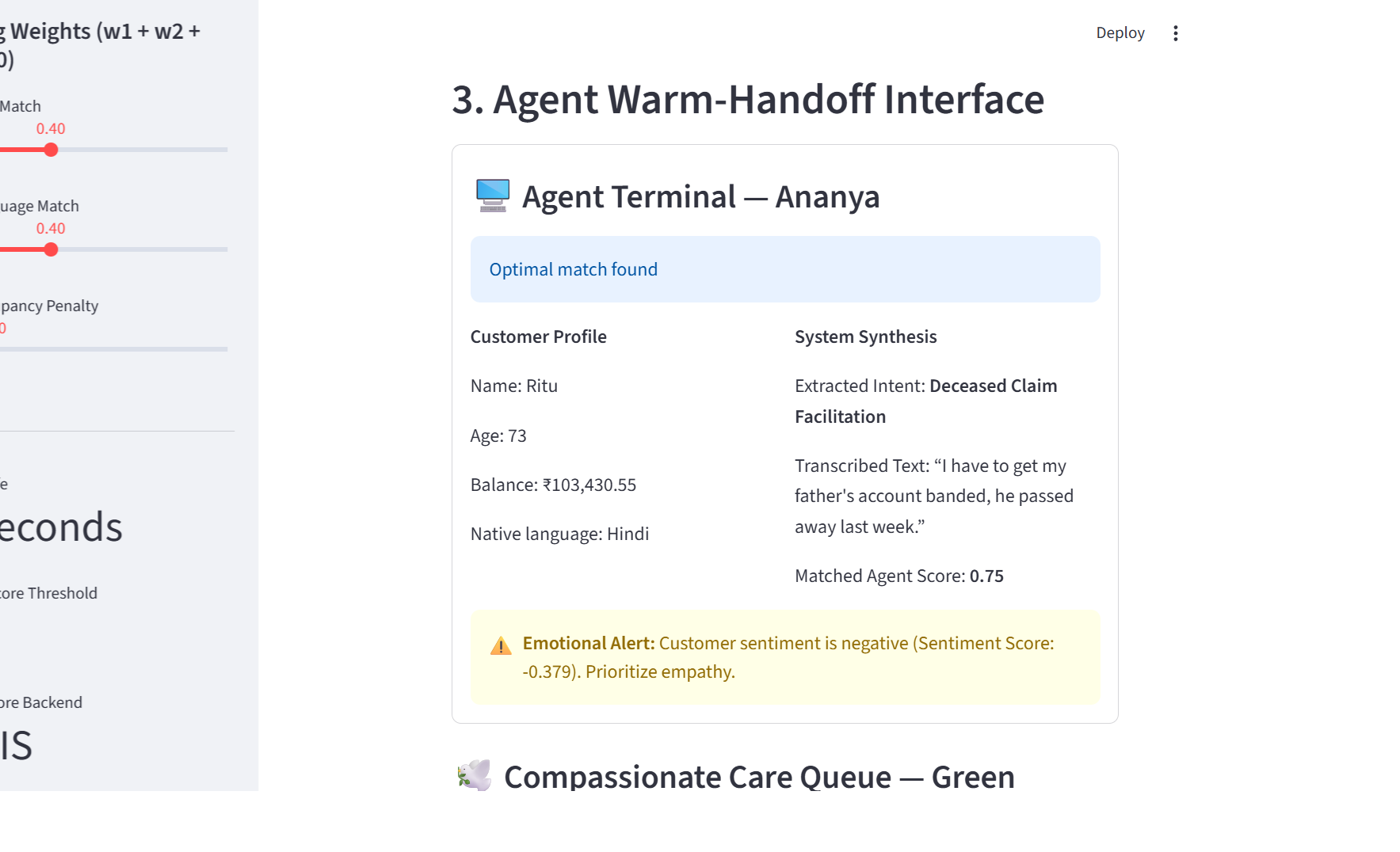
Figure 5.4: Agent Warm-Handoff Interface, showing customer profile, system synthesis, and the emotional-alert banner.

Step 5: Service-Specific Panel — Green Channel Facilitation
For the Deceased Claim Facilitation intent specifically, the agent is handed a dedicated Compassionate Care Queue checklist (Section 4.7.3): death-certificate upload and OCR verification, survivor KYC verification, and digital signing of the claim form. On completion of the automatable steps, the system issues a Green Channel Fast-Track Token, which is what allows the family to visit the branch exactly once.
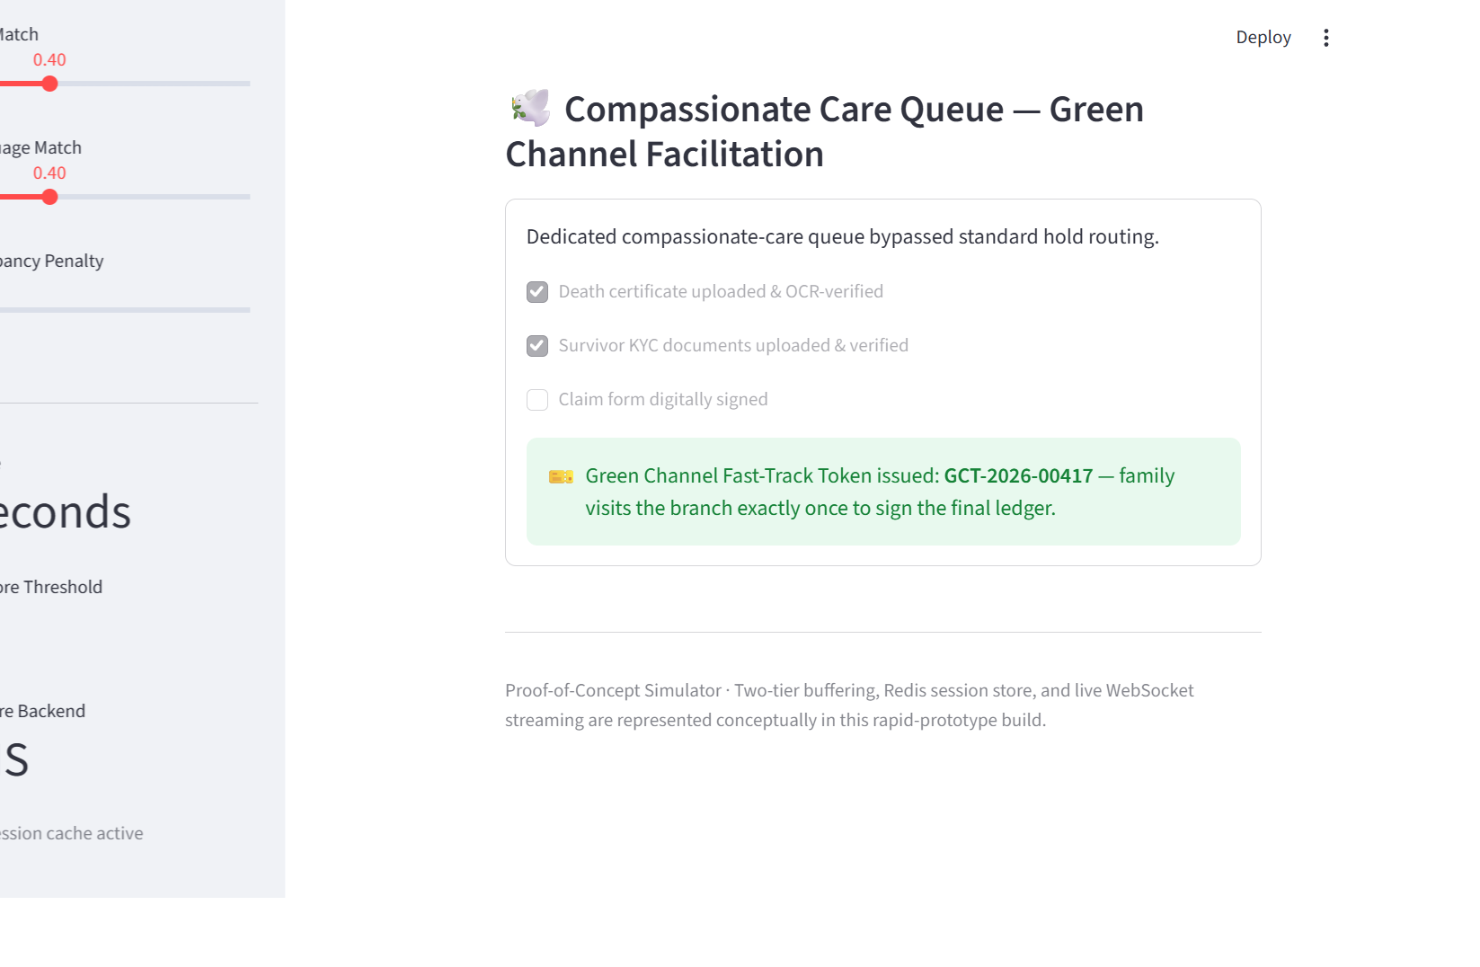
Figure 5.5: Compassionate Care Queue — Green Channel Facilitation checklist and fast-track token issuance.

5.3 Key Algorithms
Three components carry the core engineering weight of the built system, verified directly against the source:
- The routing-score calculation (Section 4.3) determines which agent is best suited to handle a given call. It is implemented as a single, self-contained function (score_agent) that operates independently of both the database layer and the user interface: it accepts a call's details as input and returns a compatibility score. This separation was a deliberate design decision, allowing the scoring logic to be tested in isolation, using arbitrary sample inputs, without requiring the full application to be running.

- The intent-classification ordering in nlp_engine.py governs the sequence in which the system checks for a caller's intent. More specific categories are deliberately evaluated before broader ones — for instance, the system checks for a Deceased Claim before checking for a routine Pension query. This ordering exists specifically to prevent a sensitive, specific complaint from being misclassified under a generic category. The safeguard is effective in most cases but not universally so; Section 5.5 documents one test case in which it did not hold.

- The sentiment safety-net override corrects the system's emotional reading when a customer's message contains high-confidence distress or fraud-related vocabulary (for example, "stolen," "scared," or "fraud"). In such cases, the emotional index is forced to register as negative regardless of the underlying model's own classification, functioning as a manual correction layer over the model's output.

A scope limitation is noted here explicitly. The system records a caller's sentiment throughout a call (Section 4.1), but this history is not yet used to inform escalation — the live trigger reacts only to the most recent utterance (Section 5.2), not a trend across the call, and the transcript is processed in a single pass rather than streamed incrementally. The sentiment history is captured and displayed, but not yet read back into a live decision; this is carried forward as future work (Chapter 8).

5.4 Synthetic Data Generation
The Faker library was used to generate a 1,000-row synthetic operational call log, calibrated to reflect two real-world patterns identified in the requirements: elderly customers (age > 60) were programmed with higher wait times and lower FCR rates on the traditional-IVR channel, an effect that narrows substantially once they are modelled as using the conversational regional-language interface; and customer churn was correlated with average wait times exceeding 90 seconds combined with a failed FCR outcome, consistent with documented churn-risk patterns in the customer-satisfaction literature reviewed in Chapter 2.

5.5 Engineering Challenges and Decisions
Three notable design decisions and limitations surfaced during implementation and testing, all disclosed transparently rather than concealed:
- Decoupling sentiment from the routing score: an earlier design iteration of this project folded customer sentiment directly into the matching formula, on the reasoning that highly distressed callers should be paired with more experienced agents. In practice, this risked pulling a distressed caller away from the specialist best suited to their specific intent, toward whichever “senior” agent happened to be modelled as experienced. The as-built system instead keeps sentiment out of the score entirely (Section 4.3) and routes it directly to the agent's screen as an Emotional Alert (Section 5.2, Step 4) — preserving specialist-intent matching while still ensuring the receiving human agent is warned to handle the call with care.
- Two distinct root causes behind the manual-test failures (Section 6.1), not one: the Bengali and Tamil failures occurred on correctly translated, correctly intent-classified text — the failure was the sentiment model itself reading a clearly negative complaint (“there's an unknown transaction on my account, is this fraud?”) as Neutral. The Gujarati failure was a genuine translation/keyword-matching issue: the deliberate category-ordering safeguard described above (checking Deceased Claim Facilitation before Pension) could not help because the romanized-script translation itself never surfaced a matching phrase like “passed away,” so the classifier correctly matched the only keyword it could find (“pension account”) and returned the wrong, but locally consistent, intent.
- Sentiment-model calibration on polite or implicit distress: the Hugging Face sentiment model occasionally misclassifies text that carries genuine distress or suspicion without overtly negative vocabulary as Neutral or Positive. The keyword-based override catches high-signal cases (explicit fraud/distress vocabulary) but, as the Bengali and Tamil test failures show, does not yet catch subtler phrasing such as a customer calmly asking whether a transaction was fraudulent. Fine-tuning on banking-domain, Indian-English text is the most direct fix (Chapter 8).

Chapter 6: Testing and Results

6.1 Manual Test Suite
A 25-case manual test transcript set, spanning six languages and all nine intent categories, was used to validate the NLP pipeline under known ground-truth conditions, with every case independently logged for expected vs. actual intent, sentiment bucket, and routing outcome. The system passed 22 of 25 cases (88%). All 3 failures originated in the sentiment or intent-classification layers, not the routing-score computation itself — in every case, including the one where the extracted intent was wrong, the routing engine faithfully applied the formula in Section 4.3 to whatever intent and language it was given (verified directly: the Gujarati failure's routing score of 0.42 reconstructs exactly from its language match and the mis-extracted intent's specialty requirement). Of the 3 failures, 2 (Bengali, Tamil) were sentiment-bucket misses on correctly translated and correctly classified text, and 1 (Gujarati) was an intent misclassification traced to a romanized-script translation gap rather than a flaw in the category-priority safeguard itself.

6.2 Primary Survey Results (n = 65)
A primary survey was independently conducted (methodology detailed in Appendix B) to quantify real customer experience with SBI's contact centre, distributed anonymously through personal and public channels via Google Forms, with no identifying information collected. Every panel of the resulting dashboard (Figure 6.1) is analysed below.
Headline Finding | Value
Respondents who had abandoned a call due to wait time or menu confusion | 83%
Respondents reporting “always” getting First-Call Resolution | 28%
Respondents who had faced friction from a language mismatch with an agent | 43%
Sample aged 41 or above | 63%

Panel-by-Panel Analysis
- Age Group Distribution: 13 respondents under 25 (20%), 11 aged 25–40 (17%), 21 aged 41–60 (32%), and 20 above 60 (31%) — meaning 63% of the sample falls in the age bands documented in Chapter 2 as most affected by DTMF friction, which is precisely the group whose experience this survey needed to capture.

- Wait Time Before Reaching an Agent: 18 respondents (28%) waited under 2 minutes, 21 (32%) waited 2–5 minutes, 10 (15%) waited 5–15 minutes, 7 (11%) waited over 15 minutes, and 9 (14%) hung up before reaching anyone at all. One in four respondents, in other words, either waited a genuinely long time or never got through.

- Keypad Menu Navigation Difficulty: 27 (42%) found it very easy, 17 (26%) somewhat easy, 6 (9%) confusing, 5 (8%) very confusing, and 10 (15%) said they simply give up and go to the branch instead. Combining the three difficult categories, 32% of all respondents find DTMF navigation difficult enough to actively avoid it — and, cross-tabulated by age, that difficulty is sharply age-graded: only 7.7% of under-25 respondents report difficulty, versus 36.4% (25–40), 38.1% (41–60), and 40.0% (above 60). Every adult age band above 25 is roughly five times more likely to struggle with the menu than someone under 25.

- First-Call Resolution Rate: 18 (28%) always get resolution on the first call, 25 (38%) sometimes do, 13 (20%) rarely do, and 9 (14%) say they never do without multiple calls. Cross-tabulated by age, resolution is not simply worse for older respondents — it is more polarised: the above-60 group has both the highest “always” rate of any older band (25%) and the highest “never” rate of any group (25%), suggesting elderly outcomes split into two very different experiences rather than clustering in the middle, unlike the under-25 group (46% always, 0% never).

- Primary Reason for Calling: general complaints (19, 29%), debit/credit card issues (17, 26%), and balance or mini-statement queries (15, 23%) together account for 78% of all calls — pension/senior-citizen services, loan/EMI queries, and unauthorised-transaction reports make up the remaining 22%. This matters directly for the system's design: the overwhelming majority of call volume is exactly the kind of routine, low-complexity query best suited to conversational self-service, meaning the addressable opportunity for deflection is large by construction, not a cherry-picked edge case.

- Abandoned Calls: 30 (46%) say occasionally, 24 (37%) say often, and only 11 (17%) say never — combining to the 83% headline figure.

- Language Barrier by Preferred Language: For respondents whose preferred language is English, Hindi, or Bengali, “no issue” is the dominant response (65–80% of each group). For every other preferred language in the sample — Gujarati, Tamil, Telugu, Malayalam, and the “Other” category — 100% of respondents report some form of friction, either having experienced it directly or having learned to pre-emptively default to English to avoid it. That is a genuinely stark finding: language friction in this sample is not a diffuse, occasional problem — it is a near-universal experience for anyone whose preferred language sits outside SBI's three most common contact-centre languages.
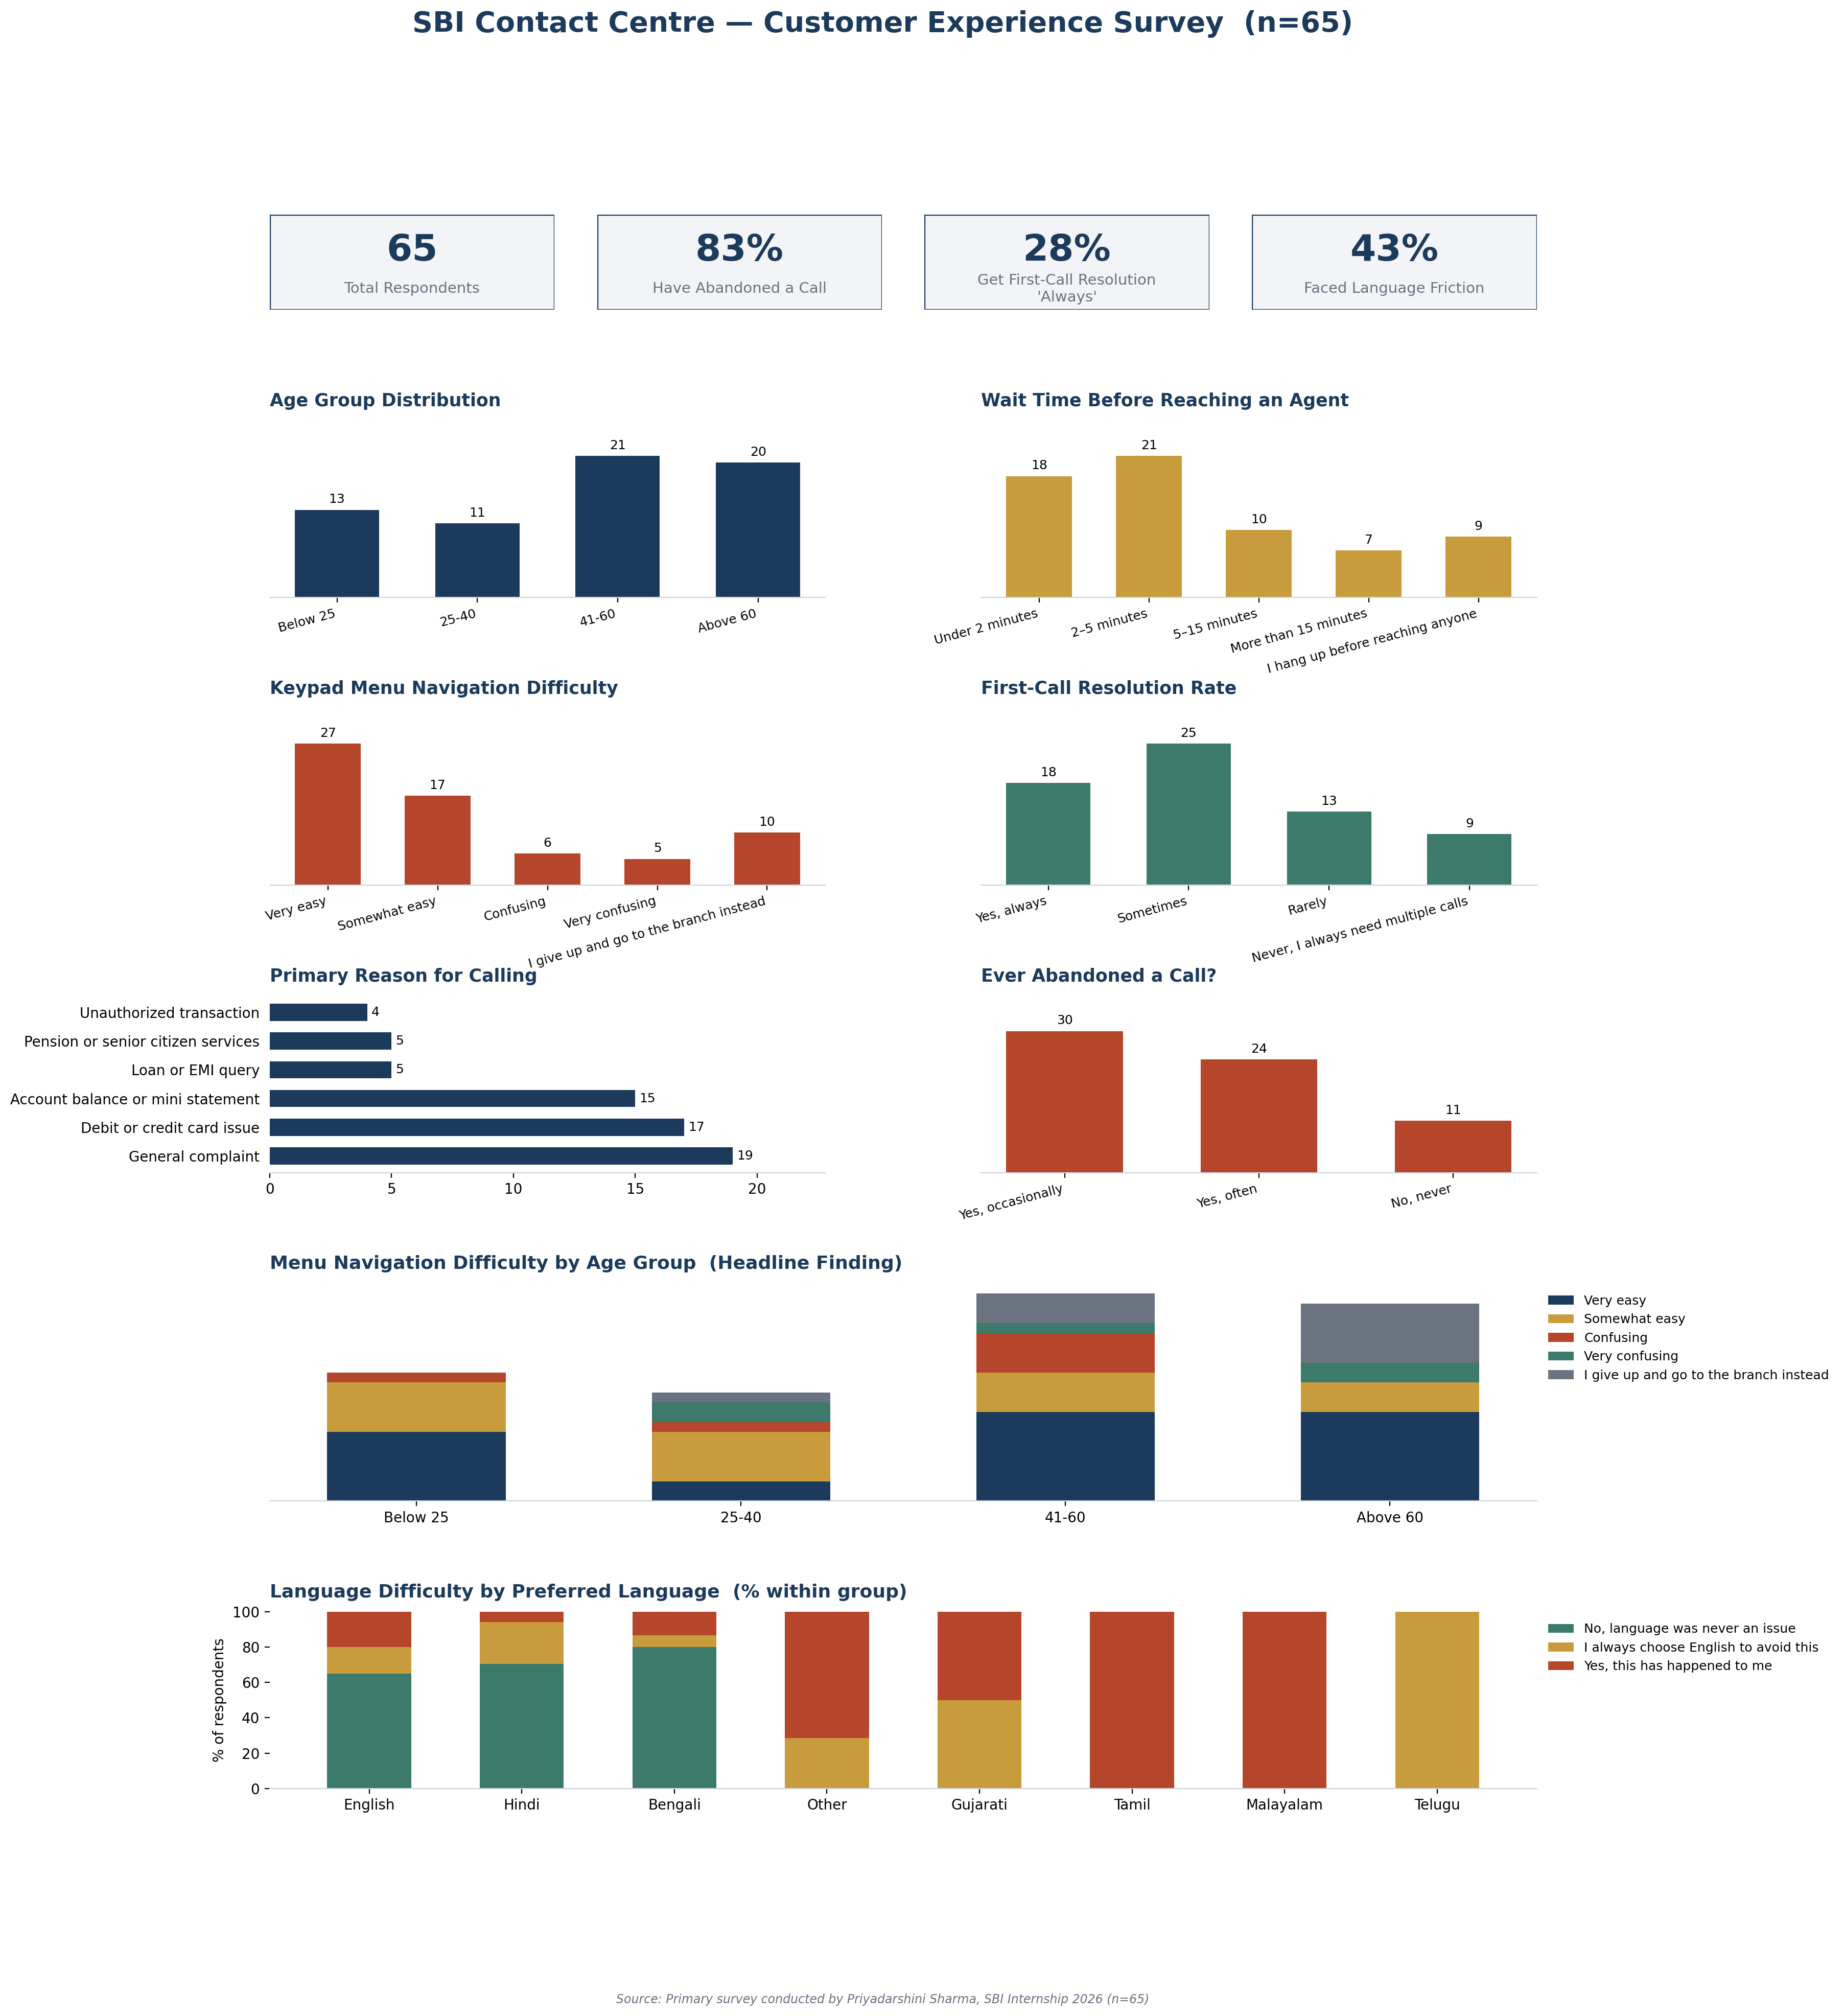
Figure 6.1: SBI Contact Centre Customer Experience Survey dashboard (n = 65).

6.3 Synthetic Operational Simulation Results (n = 1,000 calls)
A 1,000-call synthetic operational simulation compared the proposed “Conversational AI (Regional)” channel against a “Traditional IVR (DTMF)” baseline, computed directly from the underlying log rather than read off the chart:
Metric | Traditional IVR | Proposed System | Blended (All 1,000 Calls)
First-Call Resolution (FCR) | 47.8% | 78.9% | 63.6%
Churn Risk Rate | 13.6% | 3.3% | 8.4%
Branch Visits Prevented | 10.8% | 17.3% | 14.1%
Average Sentiment Improvement (final − initial) | +0.53 | +0.63 | +0.58

The dashboard's four top-line KPI cards (1,000 calls; 64% FCR; +0.58 sentiment improvement; 14% branch visits prevented) are this blended column — the average across both channels combined, since the simulation models a population where roughly half of calls still land on the legacy channel. The split columns are the more informative comparison, since they isolate what changes when a call is specifically handled by the proposed system.
Two further panels are worth walking through in detail. First, First-Call Resolution by age group declines steadily from 68.6% (18–30) to 63.3% (31–45), rises slightly to 67.4% (46–60), then falls to 61.5% (61–75) and 56.3% (76+) — a pattern directly consistent with the elderly-adoption barrier documented in Chapter 2, and the direct motivation for the Passive Voice Biometrics and YONO Companion services (Sections 4.7.1–4.7.2).
Second, and most strikingly, final sentiment holds steady and positive through 90 seconds of wait time (+0.31 at 0–30s, +0.25 at 30–60s, +0.29 at 60–90s) and then falls off a cliff beyond that point (−0.19 at 90–120s, −0.10 beyond 120s). Churn risk moves in lockstep: 1.8–3.4% for any wait under 90 seconds, jumping to 44.9% at 90–120 seconds and 61.5% beyond 120 seconds — more than a twelve-fold increase. This is the empirical basis for the churn-risk calibration in Section 5.4, and it is worth being precise about what it does and does not show: the 90-second threshold was itself a modelling assumption built into the generator, not an emergent discovery, so the cliff's exact location should be read as the project's calibrated hypothesis about where patience runs out, not as an independently observed fact about real SBI customers. The shape of the effect — a threshold beyond which patience collapses rather than a smooth decline — is nonetheless a reasonable and literature-consistent modelling choice (Chapter 2).
Call volume by intent category confirms all nine categories, including the five newly added services, received meaningful simulated call volume (91–129 calls each, out of 1,000 total), and calls were generated in roughly equal numbers across all six modelled regions (156–184 each) — ruling out any single region or service category dominating the results by construction.
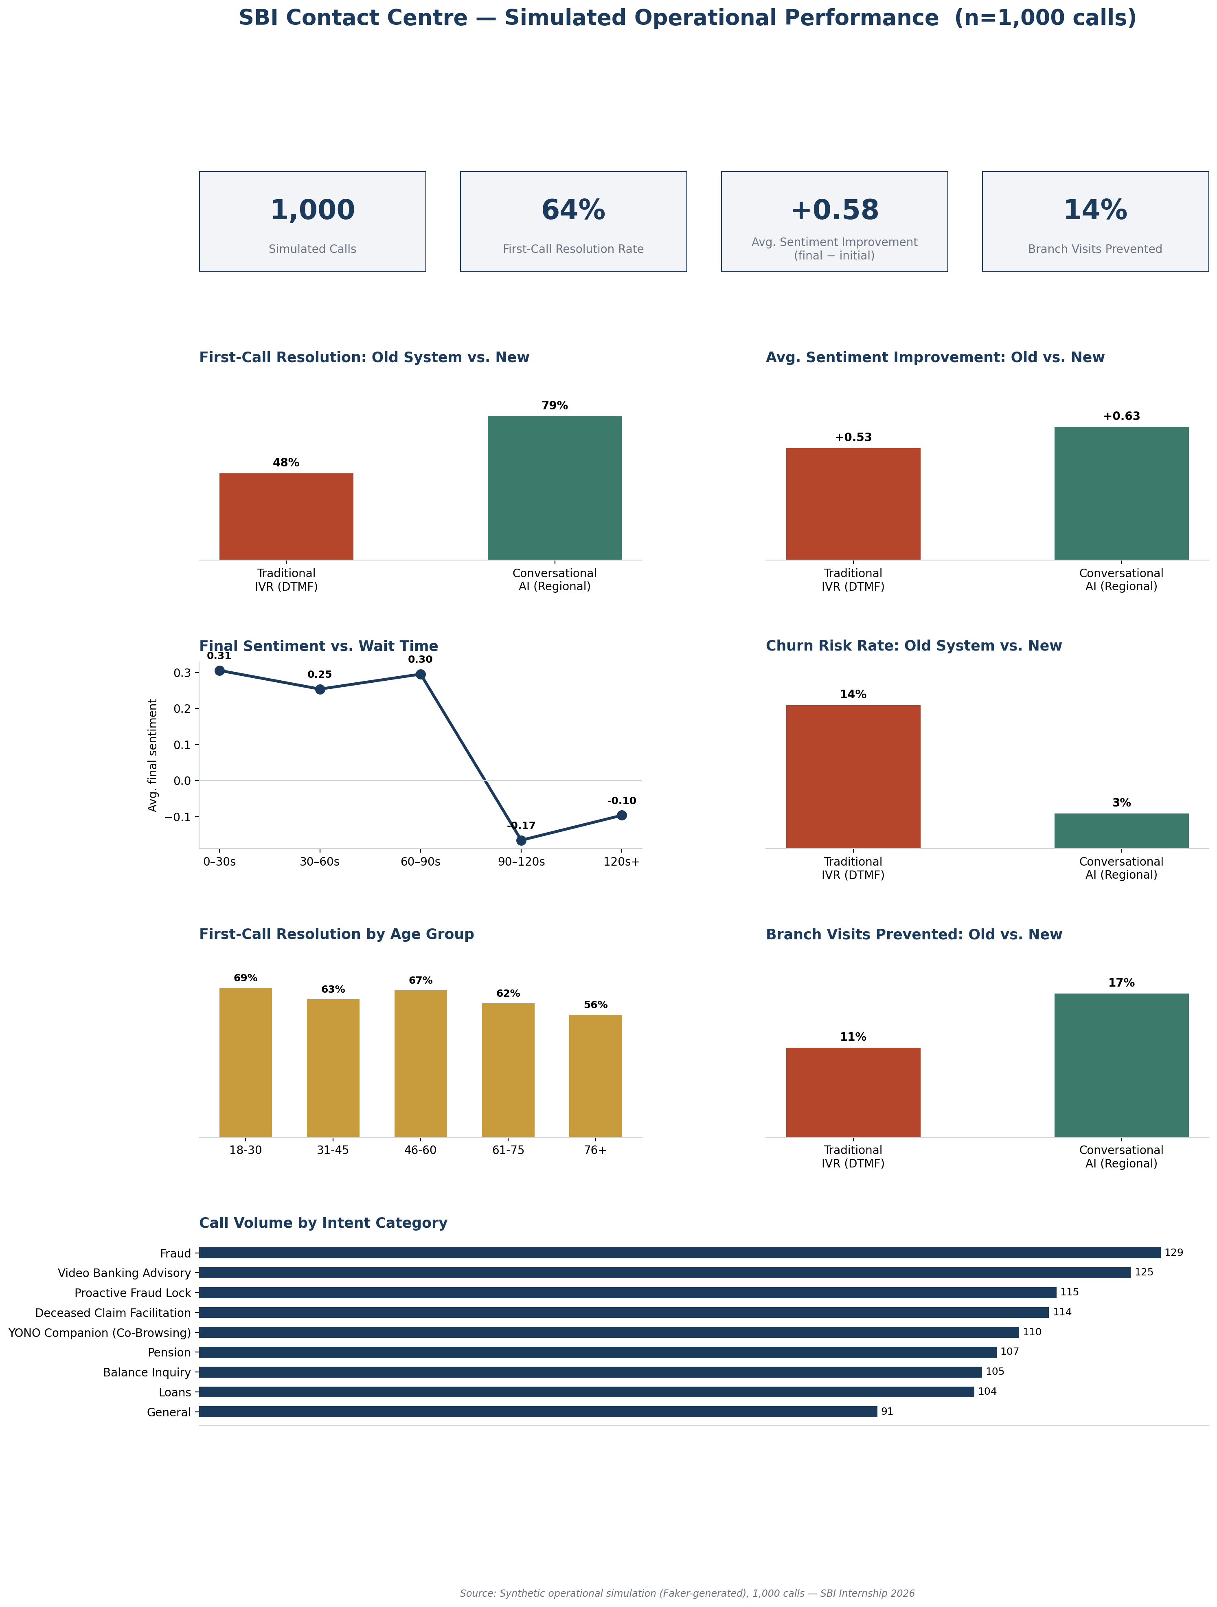
Figure 6.2: SBI Contact Centre simulated operational performance dashboard (1,000 calls).

These results should be read as illustrative of the design's intended effect rather than as a field-validated production outcome, since the underlying data is synthetic and calibrated by the project's own assumptions (Section 5.4). Nonetheless, the direction and relative magnitude of improvement are consistent with the adoption-theory predictions discussed in Chapter 7: improvements concentrate specifically where ease-of-use and perceived usefulness were most deficient in the baseline system.

6.4 Comparative Assessment: Why the Proposed System Outperforms the Existing Channel
Bringing together the manual test suite (Section 6.1), the primary survey (Section 6.2), and the operational simulation (Section 6.3), a few observations are worth drawing out about what these results do and do not show.
- The design targets a specific, measured pattern, not a general assumption. The survey identifies DTMF navigation difficulty as roughly five times more common in every adult age band above 25 than under it (Section 6.2); the operational simulation reflects this same pattern in its FCR-by-age breakdown (Section 6.3). The system's core design choice — replacing menu navigation with conversational, multilingual input — was aimed at this specific, survey-observed barrier.

- The routing logic itself was tested, not just designed. The 25-case manual test suite (Section 6.1) shows the routing algorithm produced a correct match in every case where it received a correctly-classified intent; all three failures traced back to the upstream sentiment or translation layers. This is a modest but meaningful result: it means the routing component specifically works as intended, within the scope this project was able to test.

- The simulated gains are concentrated where the modelled baseline is weakest. Within this simulation, FCR is 31 percentage points higher on the conversational channel than the traditional-IVR baseline (47.8% vs. 78.9%), and churn risk is markedly lower (13.6% vs. 3.3%). These are results from a synthetic, self-calibrated comparison built for this project, not a live A/B test against SBI's actual production system — so they should be read as evidence that the design addresses the intended problem in simulation, not as a claim about any currently deployed infrastructure.

Chapter 7: Discussion — Adoption Implications

7.1 Mapping Results to Adoption Theory
Read against the TAM/UTAUT framework introduced in Chapter 2, the system's design choices target the two factors that Indian e-banking research has found to significantly predict adoption intention — performance expectancy and effort expectancy — rather than simply adding a facilitating condition (a channel that exists but is hard to use). Replacing DTMF navigation with conversational, multilingual interaction directly reduces effort expectancy; sentiment-aware escalation and predictive routing directly increase performance expectancy by improving the odds of first-call resolution.

7.2 Who Benefits Most
The synthetic simulation's calibration (Section 5.4) and the survey results (Section 6.2) both point to the same two segments as primary beneficiaries: elderly customers, for whom DTMF navigation is a well-documented barrier independent of network quality; and regional-language speakers, for whom the existing English/Hindi-centric routing produces the language-friction outcomes reported by 43% of survey respondents.

7.3 Limitations
- This is a proof-of-concept simulation; live telephony, production Bhashini integration, and a production Redis cluster are mocked or represented as local equivalents.
- The primary survey (n = 65) is not large enough to support strong statistical claims and should be read as directionally indicative rather than representative of SBI's full customer base.
- The synthetic operational data is calibrated by the project's own assumptions about elderly wait times and churn correlation; it demonstrates the system's intended effect rather than a field-measured outcome.
- Sentiment-model calibration on romanized-script and politely-phrased distress inputs remains an open technical gap (Section 5.5).

Chapter 8: Conclusion and Future Scope

8.1 Summary of Contributions
This internship produced a working proof-of-concept multilingual, emotion-aware contact-centre routing engine addressing a problem SBI's own leadership has identified as its primary contact-centre constraint: customer adoption, not capacity. The system integrates a translation-understanding-memory-decision-presentation pipeline, a predictive multi-weighted routing algorithm, and graceful degradation at every failure point, and was validated through a primary survey, a manual test suite, and a synthetic operational simulation showing directionally meaningful improvements in First-Call Resolution, churn risk, and branch-visit deflection.

8.2 Future Work
- Feeding the already-captured rolling sentiment history (Section 5.3) back into the escalation decision as a trend-based average, rather than triggering only on the single latest utterance.
- Integrating the production Bhashini ASR+NMT API in place of the mocked deep-translator pipeline.
- Fine-tuning the sentiment model on banking-domain, Indian-English and romanized-script text to close the gap identified in Section 5.5.
- Implementing true WebSocket-based real-time call streaming in place of the current transcript-batch simulation.
- Running an A/B testing framework to empirically tune the routing-score weighting coefficients (w1, w2, w3) against live queue data.
- Validating the synthetic-simulation findings against a live shadow-pilot on a single queue, per the phased deployment strategy outlined during the design phase.

REFERENCES
1. Indian banks: Navigating through the turbulence. McKinsey & Company. https://www.mckinsey.com/industries/financial-services/our-insights/indian-banks-navigating-through-the-turbulence
2. Das, S. Current issues in the Indian banking and financial sector. Bank for International Settlements. https://www.bis.org/review/r240722g.htm
3. Contact Centre — Customer Care, SBI Bank. https://sbi.bank.in/web/customer-care/contact-centre
4. SBI revamps Contact Centre Service for personalized customer experience. Passionate in Marketing / Elets BFSI (2022).
5. Bhashini.ai API Documentation. https://www.bhashini.ai/docs
6. ai4bharat/IndicBERTv2-alpha-SentimentClassification.
Hugging Face: https://huggingface.co/ai4bharat/IndicBERTv2-alpha-SentimentClassification
7. tabularis.ai/multilingual-sentiment-analysis. Hugging Face :https://huggingface.co/tabularisai/multilingual-sentiment-analysis
8. Exploring Factors Behind E-Banking Adoption in India: A UTAUT Model Study. ResearchGate.
9. Technology Adoption in Banking Sector: A Systematic Literature Review of TAM and UTAUT Models. Springer.
10. A Study on the Acceptance of Mobile-Banking Applications in India — UTAUT Model. Sustainability, MDPI.
11. Barriers to Age Agnostic Digital Banking. Infosys BPM.
12. IVR Services in Bank: A CXO's Guide to AI-Powered CX. DialNexa.
13. RBI's Annual Report of the Ombudsman Scheme 2024–25. Reserve Bank of India.
14. Predictive Routing: Connecting Customers to the Right Agent Every Time Using AI. Startel.
15. How predictive routing boosts contact center efficiency. Genesys.
16. How to Build Real-Time Sentiment Analysis for Streaming Audio. Deepgram.
17. Building Real-Time AI Chat: Infrastructure for WebSockets, LLM Streaming, and Session Management. Render.
18. Intelligent Multilingual Contact Centre Engine — Source Code. GitHub. https://github.com/Priyadarshini-Sharma/sbi-multilingual-contact-centre
19. Intelligent Multilingual Contact Centre Engine — Live Demo. Streamlit Community Cloud: https://sbi-multilingual-contact-centre.streamlit.app
20. Primary Survey: SBI Contact Centre Customer Experience Survey (n = 65). Google Forms. https://forms.gle/i52EiKHTtpCxSfmt8
21. State Bank of India. Contact Centre — List of Inbound and Outbound Services (internal reference material used for gap-analysis purposes, Section 4.8).

APPENDICES

Appendix A: Sample Code — Routing Algorithm
# optimizer.py - core scoring function
# $Score_{ij}=w_{1}S_{ij}+w_{2}L_{ij}-w_{3}O_{j}$
def _skill_match(agent_specialties, intent):
"""1.0 if agent holds the required specialty, 0.5 if General, else 0.1"""
required = _INTENT_TO_SPECIALTY.get(intent, "General")
specialties = [s.strip() for s in agent_specialties.split(",")]
if required in specialties:
return 1.0
if "General" in specialties:
return 0.5
return 0.1
def _language_match(agent_languages, detected_language):
"""Binary: 1.0 if agent speaks the caller's language, else 0.0"""
langs = [l.strip().lower() for l in agent_languages.split(",")]
return 1.0 if detected_language.strip().lower() in langs else 0.0

def score_agent(agent, intent, language, weights):
s = _skill_match(agent["specialties"], intent)
l = _language_match(agent["languages"], language)
o = agent["workload_score"]
return weights["w1"]*s + weights["w2"]*l - weights["w3"]*o

Appendix B: Survey Questionnaire
Administered via Google Forms (https://forms.gle/i52EiKHTtpCxSfmt8), fully anonymous, n = 65:
1. What is your age group?
2. Which language do you prefer when speaking to a bank representative?
3. How often do you contact SBI customer care?
4. What is your primary reason for calling SBI customer care?
5. When you call SBI's toll-free number, how easy is it to navigate the keypad menu (press 1 for this, press 2 for that)?
6. Was your issue resolved on your first call without being transferred?
7. On average, how long do you wait before speaking to a human agent?
8. Have you ever abandoned a call because the wait was too long or the menu was too confusing?
9. Have you ever had difficulty because the available agent did not speak your preferred language?

